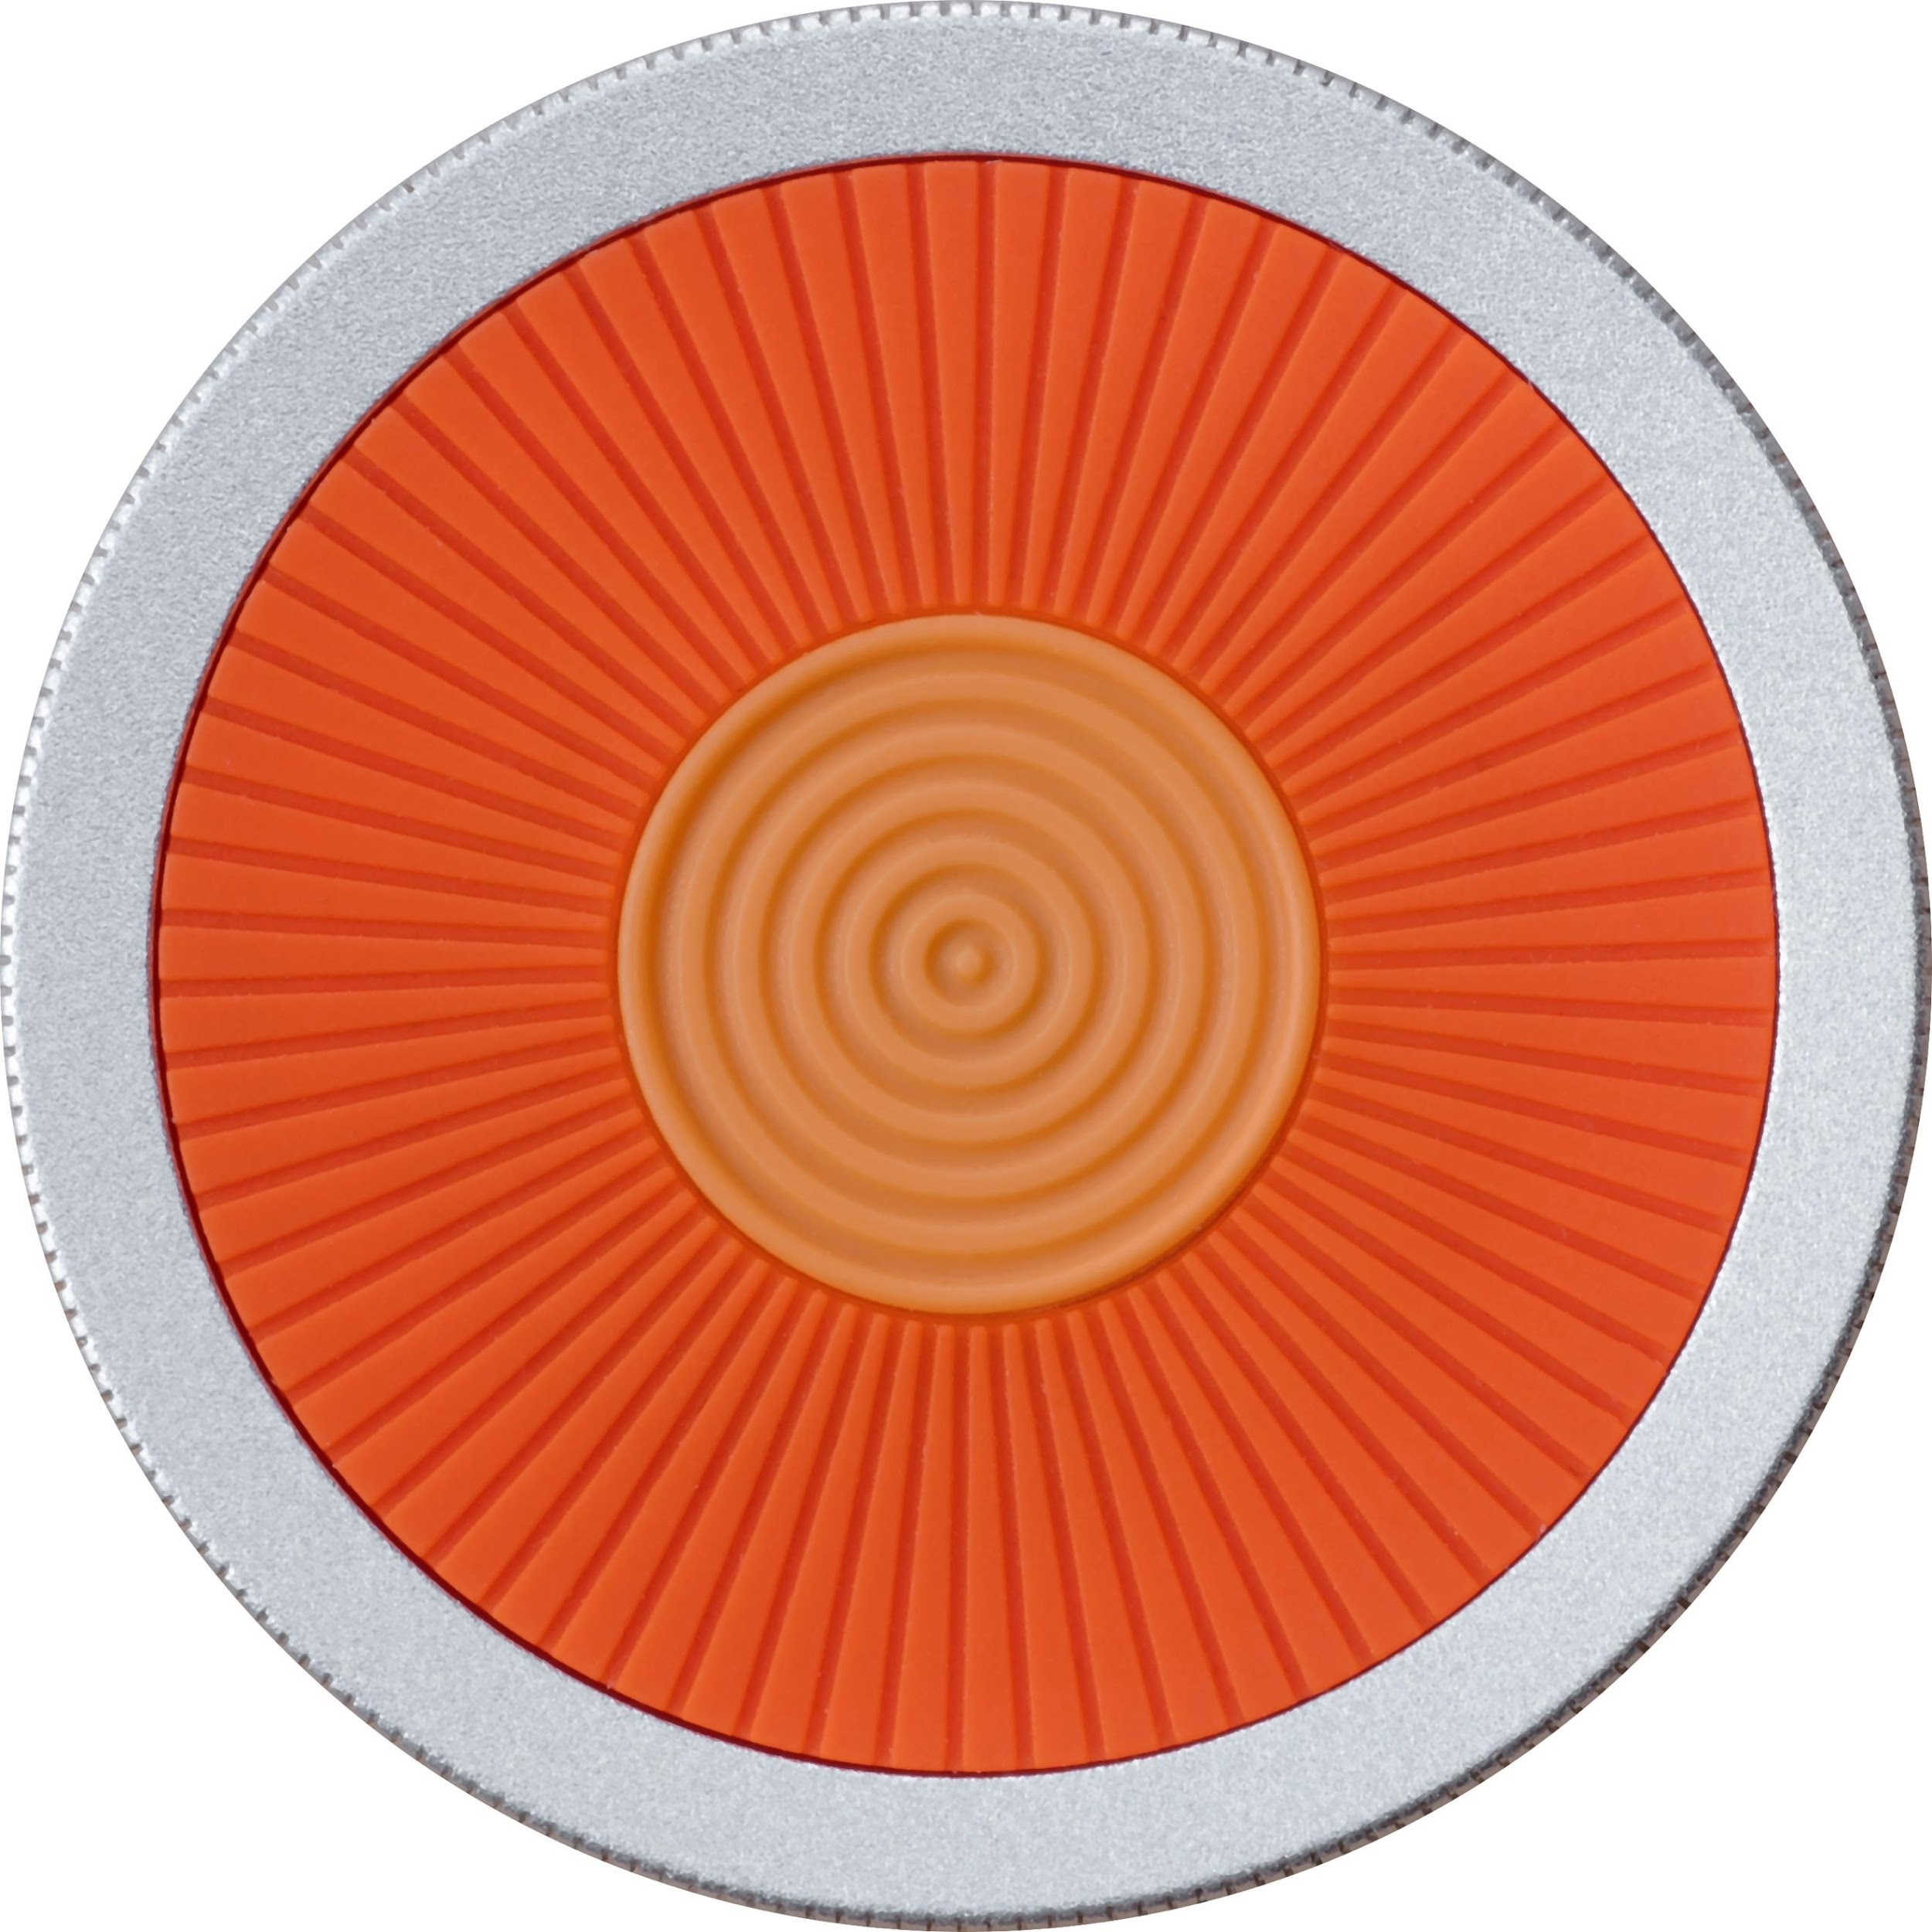

USER GUIDE

Everything you need to know about O6

Contents
Getting Started 5
What’s Included in the O6 Box 6
O6 Accessories 6
Steering Wheel Mount 7
Clip Mount 8
Quick Start Guide 10
O6 Device Overview 13
Charging your O6 15
Connecting O6 to your iPhone via Bluetooth 16
Installing the O6 app 16
Updating O6 Firmware 17
Using your O6 Device 18
Using O6 with the O6 App 18
Activating Siri for Voice Commands 18
O6 Modes 19
Basic Mode 19
Smart Response Mode 21
Volume Mode 21
Advanced Modes 22
Media and Settings Mode 26
Using the O6 App 28
O6 App Channels 28
Email Channel 29
Notifications Channel 29
Twitter Channel 30
NPR One Channel 30
Pocket Channel 31
Contacts Channel 33
O6 App Settings 34
Choosing Different Voices for O6 App 35
Performing Actions using O6 36
Overview of how Actions Work 37
Configuring the iPhone for O6 Internationalization 38
Using the O6 App without the O6 Device 38
Security and Privacy 39
FAQ’s 39
How do I connect my O6 device to my iPhone? 39
Does O6 support Android? 39
What languages does O6 support? 39
How is O6 different from Apple’s Siri or other Voice Command Systems? 39
Does O6 have a speaker? 40
What is the Battery Life on the O6? 40
Where can I use O6? 40
How is O6 “eyes free”, when the video shows the app while driving? 40
Why the name O6? 40
Why are there two different modes of interacting with apps, when they do similar things? 40
How do I change the volume? 41
How do I check the battery level? 41
How many O6’s can I connect to one iPhone? 41
Technical Specifications 43
New User Setup Tips 44
Future Developments 45

Overview
Congratulations on owning an O6, an entirely new way to stay connected without looking at or touching your phone.
The world has changed drastically in the last 10 years. With ubiquitous Wi-Fi and robust cellular plans, we have gone from “work phones” and desktop computers to being always connected, whether we are walking to work or the grocery store, working out or even driving.
People’s dependence on smartphones is utterly complete. Unfortunately, this dependence does not end when we step outside or open a car door. At this very moment, over 660,000 Americans are handling their phones - checking email, scrolling through twitter - while driving.
We can’t stop people from feeling the need to check their email and social media, but O6 does something that no other product can do - it allows them to do it without taking their eyes off the road - as simply and easily as they flip through radio stations in their car. O6 demonstrates a keen awareness of aesthetic form, precision engineering and craftsmanship that produces a very satisfying touch experience. The moment you hold the O6 in your hand, you’ll notice the quality and care that has gone into making this product.
Our goal is to make driving and even walking safer, one O6 at a time.

Getting Started

What’s Included in the O6 Box

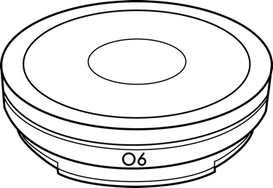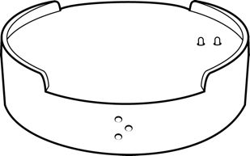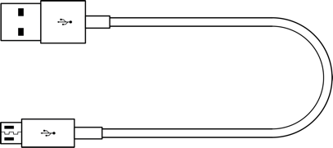

Your O6 box contains the O6 Device, O6 Charging Dock, USB Cable, and a Quick Start Guide.

O6 Accessories
O6 accessories are sold separately at o6app.com. New accessories will be added over time, so please check o6app.com to stay updated.

There are two optional accessories currently available:
- The Steering Wheel Mount

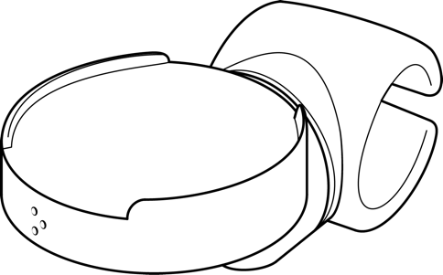

- The Clip Mount

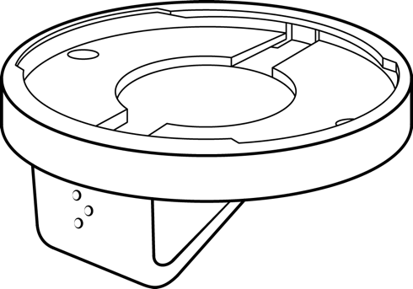
Note that your O6 only fits into the Steering Wheel Mount and the Clip Mount when it is correctly aligned and in the correct orientation. Instructions on how to do this follow below.

Steering Wheel Mount
To fit your O6 on your Steering Wheel Mount:
- Insert the O6 device into the Steering Wheel Mount.
  - Align the O6 logo on your O6 device with the Braille dots on the Steering Wheel Mount.

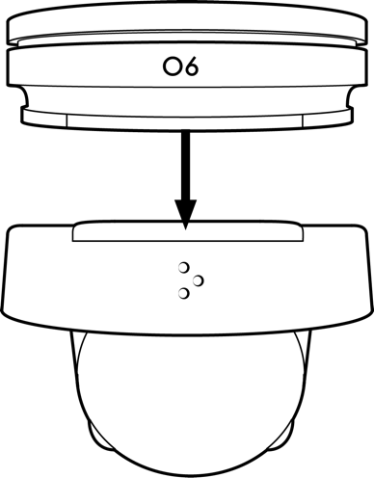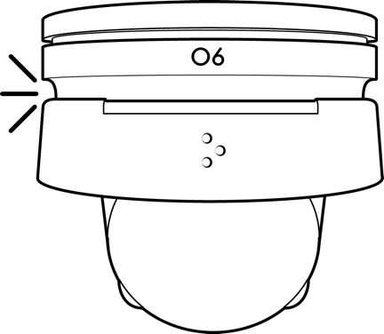

  - The O6 attaches to the Steering Wheel Mount magnetically to facilitate easy removal and portability. However, the O6 device is susceptible to dislodging if your hand collides with it.

- Fit the Steering Wheel Mount grip onto the steering wheel.

  - The Steering Wheel Mount has a flexible clamp, so do not hesitate to apply pressure. It is designed to grip the steering wheel tightly to resist accidental movement. The mount also has a rotating mid joint to adjust for comfort.

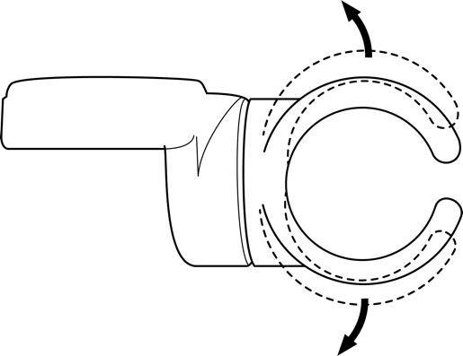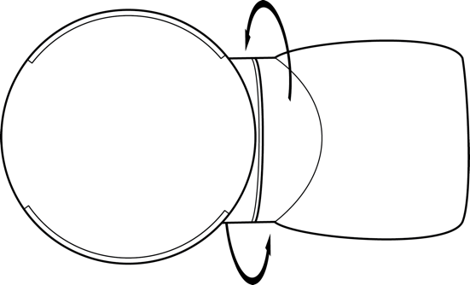

  - Clamp to your car’s steering wheel. It can be attached to various positions for comfort.

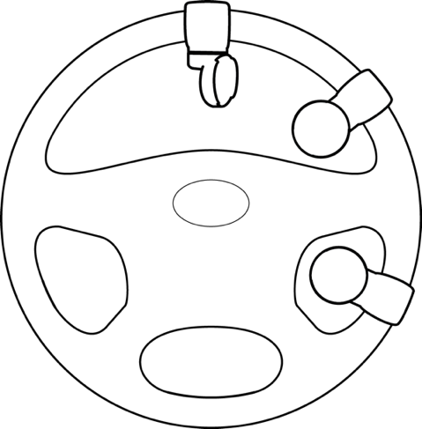

  - Use your thumb on the side of the dial to rotate the O6 bezel.

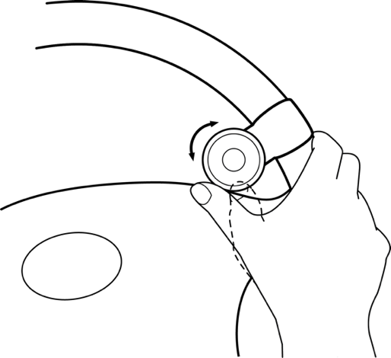

Clip Mount

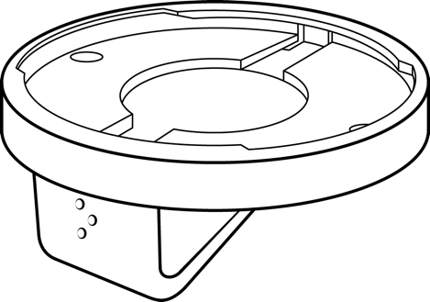

You can use your O6 on the go by wearing it on your pocket, belt, or messenger bag strap, or seat belt using the Clip Mount.

To securely mount your O6 on your Clip Mount:
- Align the O6 logo on your device at a 90 degrees angle to Braille (three dots) logo on the Clip Mount.

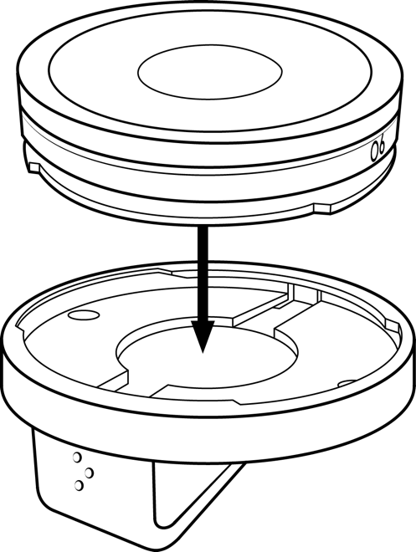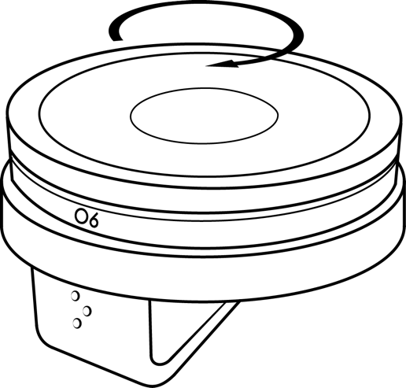

- Twist clockwise 90 degrees to lock the O6 into the groove on the Clip Mount.

- You can also use your O6 on the go by wearing it on your pocket, belt, messenger bag strap, or seat belt using the Clip Mount.

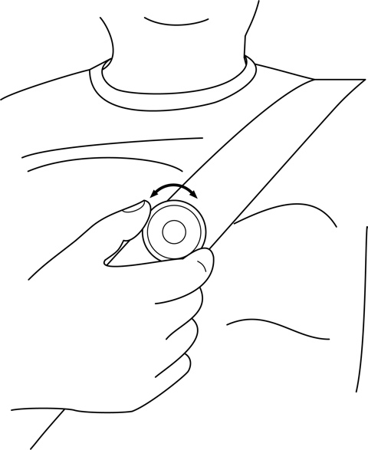

Quick Start Guide
- Charge O6 until the light turns blue.

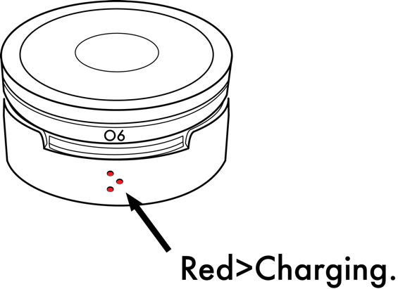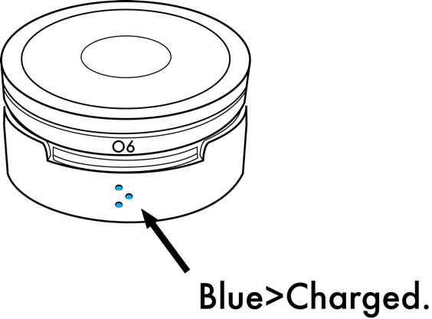

- Pair your phone and O6 via Bluetooth.
  - Open the Bluetooth settings on your iPhone.
  - Click the Center button on your O6.
  - Tap O6 on the phone screen and then tap Pair.
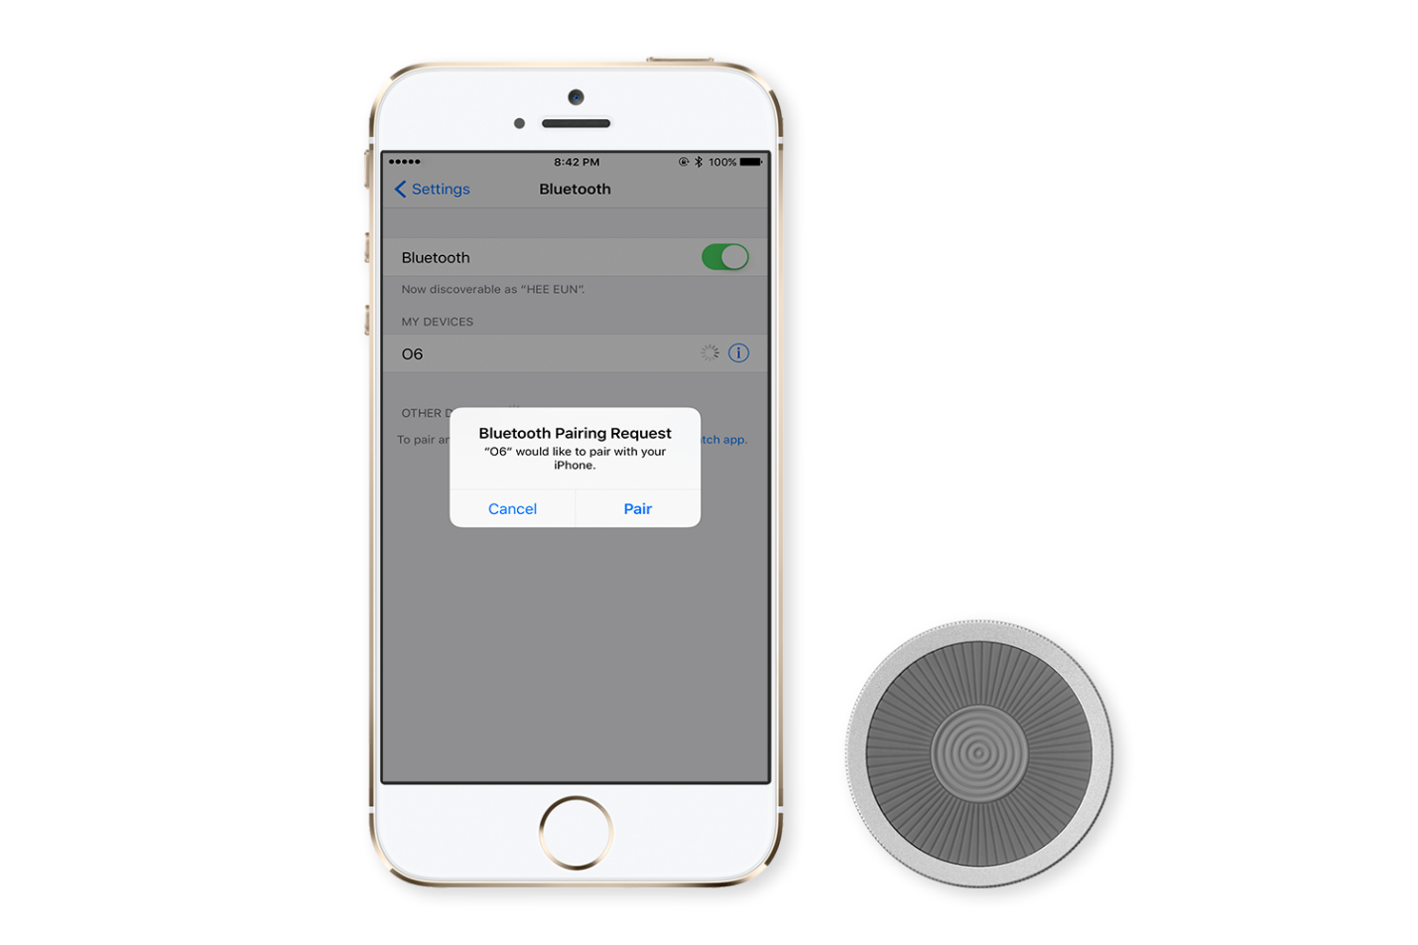

- Download the O6 app from the App Store and log into your channel account

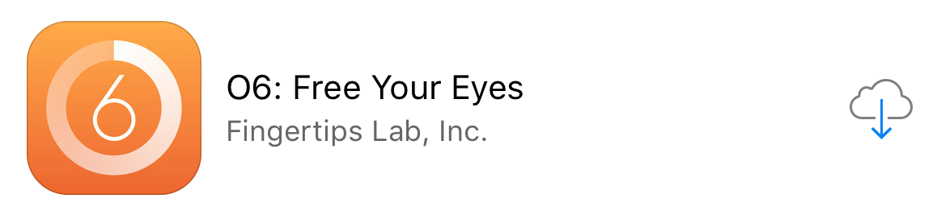

- On your phone, open a music player such as Spotify.
  - Click the Center button to Play/Pause.

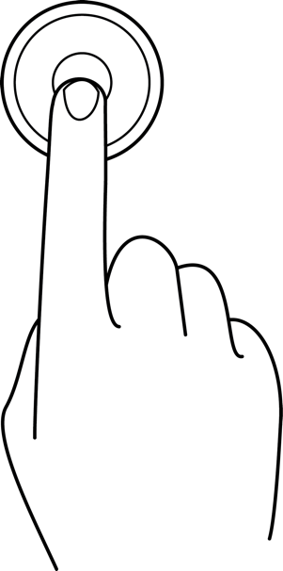

  - Rotate the O6 bezel dial to change tracks. O6 is designed to facilitate single-handed operation as well two-handed operation.

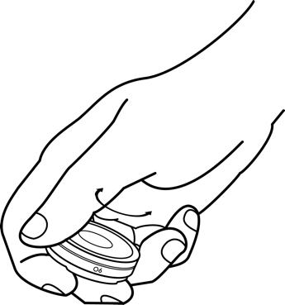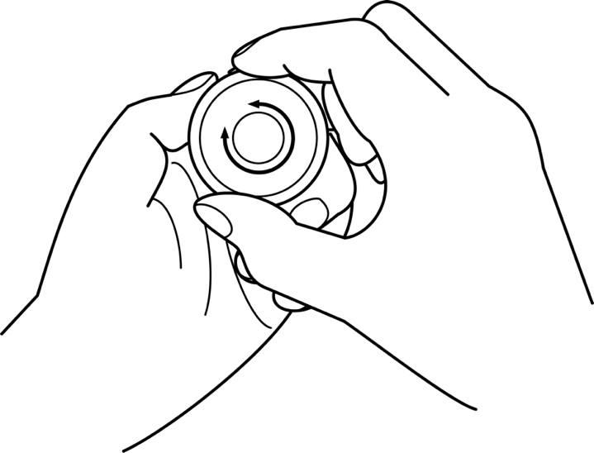

  - Press and Rotate the O6 bezel dial to change volume

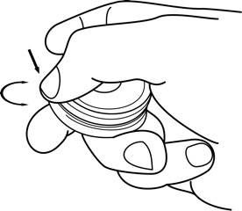

- Operate the O6 app from the device.
  - Open the O6 App on your phone.
  - Click the Center button on the O6 to Play/Pause content or select a channel.
  - Double-click the Center button to bring up the Actions menu.
  - Rotate the dial to change tracks.
  - Click the Ring button to get back to the Main menu or to exit the Actions menu.

- Answer an incoming call by pressing the Center button on your O6.
- Decline an incoming call by pressing the Ring button.
- Press and hold the Ring button to activate Siri at any time.
- Shutdown O6 by pressing and holding the Center button for 5 seconds until you feel the ramp down haptic buzz. Wake up the O6 by pressing the Center button once.

O6 Device Overview
Watch the O6 Device Basic Functions video on YouTube for a demonstration of how the O6 works.

Your O6 lets you choose channels “eyes-free” through speech feedback. In addition, it has a multi-functional bezel dial and two tactile buttons:
- Center button

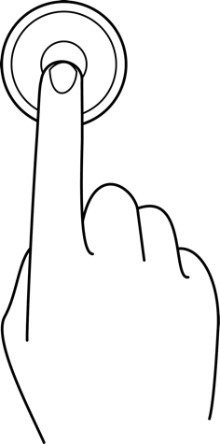

- Ring button – The donut shaped button around the Center button. It is one uniform button and it performs the same action no matter where you click on the ring. This hallmark design results in its orientation independence.

- Bezel button / dial – The thin peripheral metal dial is called the Bezel dial. This dial also acts as a button, though in most of the O6 modes, the Ring and Bezel buttons are programmed to perform the same function. Their functionality can be separated in the advanced modes (more on this later).
As a dial, it is used to scroll through lists, such as menu items or emails.

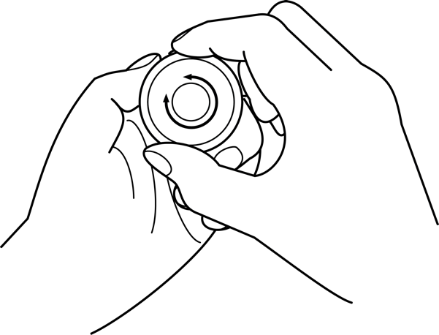

These controls can be used in multiple ways to achieve a range of functionality:
- Single-click the Center button – Play/Pause music, select a Menu item in the O6 App, or Play/Pause a content item, such as an email, in the O6 App.
- Double-click the Center button – Brings up Actions in the O6 App.
- Single-click the Ring button or Bezel dial – Takes you back to the Main menu in the O6 app, allows you to escape or exit the Actions menu in the O6 App, or takes you to your Favorites in Sonos.
- Turn Bezel Dial Clockwise or Counter Clockwise – Next or Previous track.
- Press the Bezel or Ring dial and turn clockwise or counter clockwise– Increase of decrease volume.

Charging your O6
Although your O6 comes partially charged from the factory, it is best to fully charge your O6 before first use. O6 takes about 2 hours to fully charge from an empty state.
To charge your O6:
- Plug the USB cable into the O6 Charging Dock with the correct orientation. You need to align the O6 logo on your O6 with the Braille dots on the charging dock.

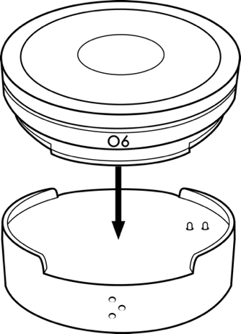

- Connect the USB cable to a USB port on your computer or any standard USB wall charger (not included).

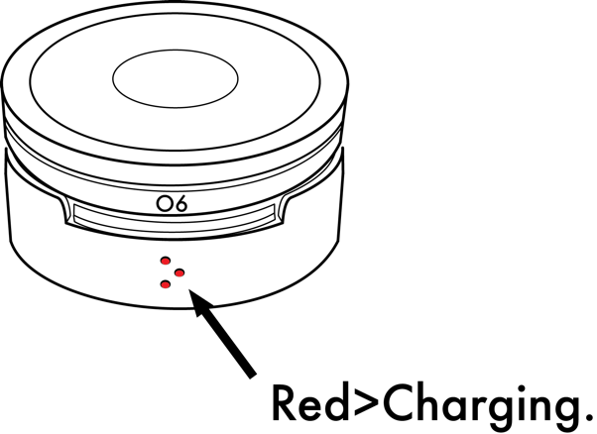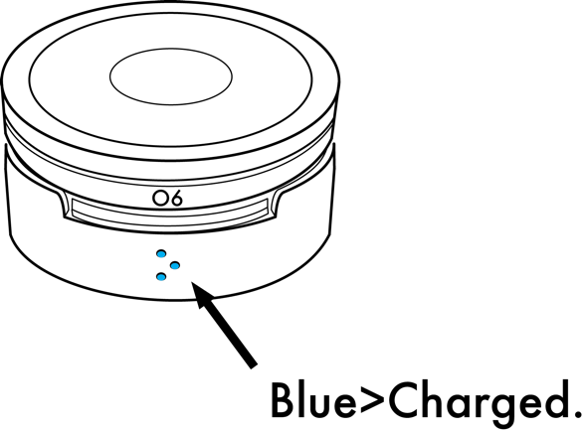

Tip: Your O6 can take up to 2 hours to charge from a fully discharged state.

Tip: You can monitor your Battery state of charge from the iOS Widget on your phone; the O6 needs to be connected to your iPhone to display the correct battery charge state (see the next section for how to connect your O6 and iPhone).

Connecting O6 to your iPhone via Bluetooth
Watch Connecting O6 with your Phone on YouTube for a demonstration.
To pair (connect) your O6 with your iPhone:
- Open Settings on your iPhone.
- Tap Bluetooth.
- Set Bluetooth to ON and keep the Bluetooth settings screen open.
- Click the Center button on the O6.
- O6 should appear under MY DEVICES.
- Tap O6 under MY DEVICES and then tap Pair in the popup (as shown in the screenshot below).
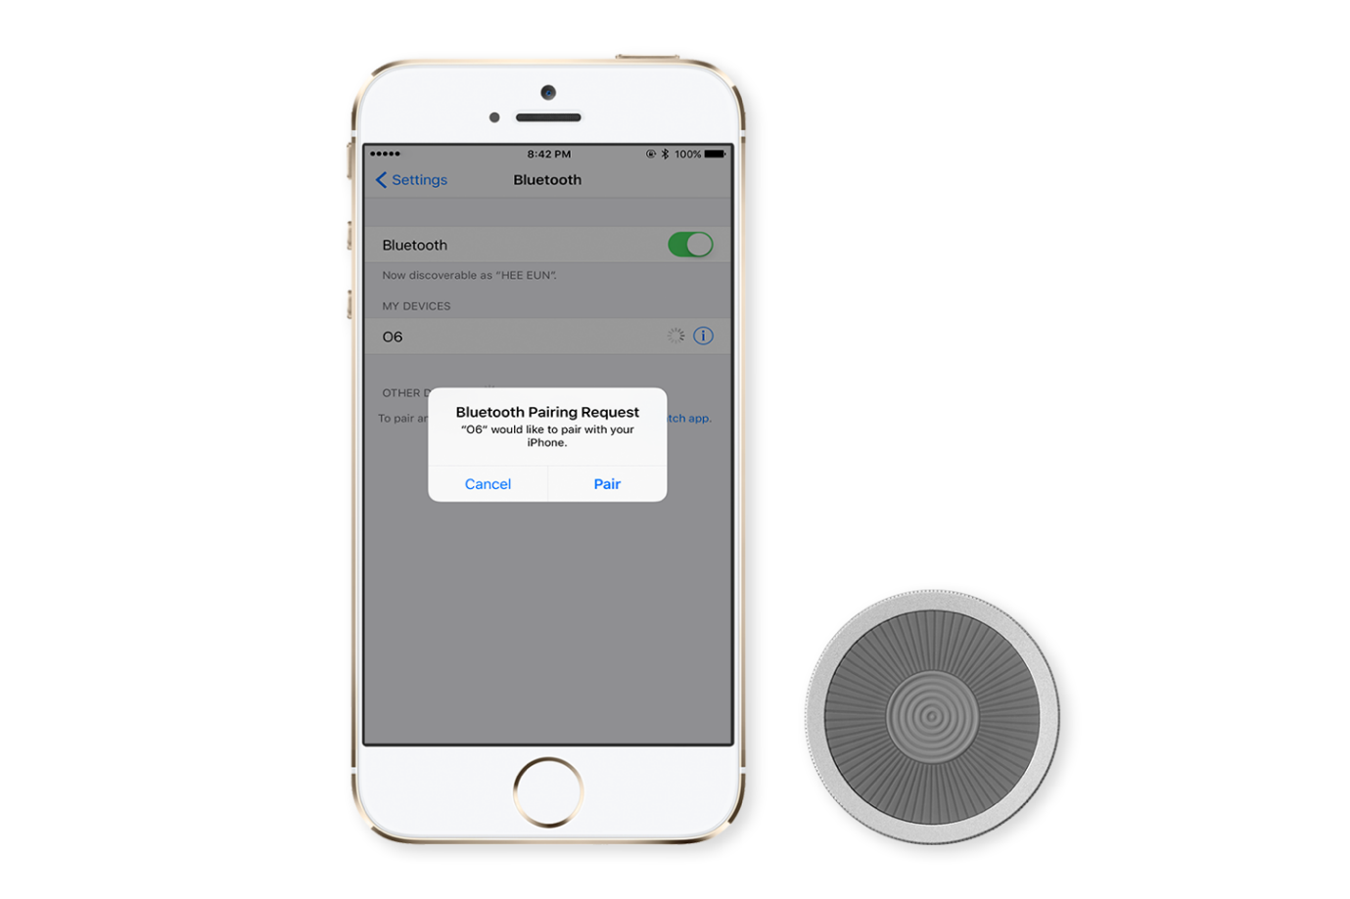
Tip: If O6 does not show up under MY DEVICES when you click the Center button, please wait a few minutes and try again.

Installing the O6 app
Watch the Setting Up O6 App YouTube video for a demonstration.
You can search for the O6 app in the App Store. If the O6 app is not available in the App Store, you will receive an email from Apple inviting you to join the O6 TestFlight team. Apple will guide you through the steps to install O6 using TestFlight.
After downloading the O6 app, please log into your accounts.

Tip: O6 runs a Beta program that tests new features before launch. Please contact hi@o6app.com if you would like an app invitation so you can test and provide feedback on advanced features.

Tip: For Beta app invites, please open the email on your iPhone.

Updating O6 Firmware
You can check whether your O6 is up-to-date at any time by going to the Settings channel of your O6 app. If the settings display the O6 device as having a newer version of firmware available, please go ahead and update it. The update process takes a few minutes, and the O6 device buzzes continuously after the update is complete. You might need to turn Bluetooth Off and On after a major release to complete the firmware update process.

Tip: The O6 needs to be connected via Bluetooth to your iPhone for the O6 App to correctly display whether a firmware update is available and for the O6 App to complete the firmware update.

Tip: There is sometimes an issue when the firmware update does not start, even though the O6 device is connected. To resolve this issue, please click the HOME button and then bring the O6 App to the foreground again.

Using your O6 Device

Using O6 with the O6 App
You can use O6 to navigate and perform the following tasks in the O6 App:
- Select a channel – Click the Center button to select a channel (e.g., email, Twitter, NPR One).
- Toggle Play/Pause – Within a channel, click the Center button to Play/Pause.
- Go to the next track – Rotate the dial clockwise to go to the next track.
- Go to the previous track – Rotate the dial counter-clockwise to go to the previous track.
- Bring up the Actions menu – Within a channel, double-click the Center button to bring up the Actions menu.
- Go back to the Main menu or exit the Actions menu – Click the Ring button to go back to the Main menu or to exit the Actions menu to resume content playback.
Please check out the O6 App section to learn more.

Tip: The O6 App runs in the background, even when the phone is locked. With a little practice, you can use O6 without looking at your phone!

Activating Siri for Voice Commands
You can use Siri to open any app, including the O6 App, and to respond to emails or send messages.
Press and hold the Ring button to activate Siri.

Tip: Even though you can use Siri to switch between apps, you might need to tap the Play/Pause button on your phone once to bring playback control to the foreground.

Important: Due to compliance issues with Apple iOS version 10, we’re proactively working to restore the Siri functionality using O6. A software update on O6 temporarily disables Siri functionality until the issue is resolved by Apple. If however Siri is enabled, in some situations, after activating Siri using the O6, the iPhone stops responding to O6. You have to unpair and repair O6 to resume normal operations. We are actively working with Apple to resolve this issue.

O6 Modes
O6 is a versatile controller that contains many modes, for example:
- Basic Mode – This is the default mode that will be active on receiving your O6. It is used to control your music and media apps, including the O6 app.
- Advanced Mode – This is used for control of your entire iPhone experience using iOS VoiceOver. You can learn more about that in the Advanced mode section.

You can switch between modes by triple-clicking the HOME button (requires iPhone HOME button triple-click accessibility shortcut set to iOS VoiceOver) on your iPhone. Haptic buzzes indicate mode transitions. A haptic feedback buzz indicates the mode you are in:
- A single haptic buzz – Indicates you have entered the Basic Mode.
- Double haptic buzz – Indicates you have entered the Advanced Mode.

Tip: The O6 app must be active, either in the foreground or in the background, for the O6 device to complete a mode transition. Please bring the O6 app to the foreground if you do not detect haptic buzzes associated with an expected mode change.

Tip: O6 consists of different modes, and the transition into these different modes is indicated by unique haptic (vibration) buzzes. If your O6 is not behaving as expected, please change modes to check whether you are in the correct mode.

Basic Mode
You can use O6 to remotely control your favorite music or media apps, such as Spotify, Apple Music, Podcasts, Audible, Netflix, YouTube, Amazon Video, and more. The default mode in O6 is called the Basic Mode, which is used to control Music, Podcasts, and the O6 App.
Open any media app, such as Spotify, Pandora, Apple Music, Podcasts, Audible, or similar and explore the functionality listed in Table 1.

Table 1. Actions and their results in Basic mode.

Action | Result
Single-click the Center button | Toggles Play/Pause for the media.
Turn the BEZEL dial one click | Clockwise switches to the next track.  Counter-clockwise switches to the previous track.
Press bezel dial and turn clockwise of counter clockwise | Increase or Decrease Volume
Triple-click the Ring button | (Optional) Switches the O6 dial to control the volume. The transition to volume mode is indicated by a ramp-up haptic buzz and the dial can then be used to adjust the volume.  Switch O6 back to Basic Mode by triple-clicking the Ring button again.

Tip: Each subtle tactile and audio click results in one action, such as switching a track or increasing the volume.

Tip: In the middle of a song, a single click counter-clockwise of the bezel dial takes you to the beginning of the song, and another immediate single click in a counter-clockwise direction takes you the start of the previous song.

Tip: In most Podcast apps (e.g., Downcast) or Audiobook apps (e.g., Audible), each click of the bezel dial (clockwise or counter-clockwise) lets you move ahead or back by 30 seconds, allowing you to easily rewind or fast forward through your audio content.

Action | Result
Single-click the Center button | Select a channel or toggles Play/Pause track
double-CLICK the center button | Bring up Actions in the Email channel
Triple-click the CENTER button | Unhide the onscreen keyboard
single-click the ring button | Go back to main channel menu or exit the actions menu
Turn the BEZEL dial one click | Clockwise switches to the next channel or track.  Counter-clockwise switches to the previous channel or track.
Press bezel dial and turn clockwise of counter clockwise | Increase or Decrease Volume
Triple-click the Ring button | (Optional) Switches the O6 dial to control the volume. The transition to volume mode is indicated by a ramp-up haptic buzz and the dial can then be used to adjust the volume.  Switch O6 back to Basic Mode by triple-clicking the Ring button again.

Smart Response Mode
O6 provides a convenient way to answer phone calls, FaceTime, Skype, WhatsApp, and WeChat calls; turn off an alarm; or remotely act on similar notifications.

O6 automatically switches to Smart Response Mode during an incoming notification and remains in that mode until the notification disappears.
In Smart Response Mode, you can:
- Respond Yes / Accept the call – single-click the Center button.
- Respond No / Decline the call – single-click the Ring button.
For instance, during an incoming phone call (or video call such as Skype or Facetime), you can click the Center button to answer the phone call or click the Ring button to decline the call.
Tip: O6 supports a versatile haptic (vibration motor) that can play over 200 haptic effects. The device vibrates discreetly to alert you of an incoming notification.

Volume Mode
The bezel dial is normally used for changing tracks. However, if you triple-click the Ring button, your O6 switches to Volume Mode. A ramp-up haptic buzz indicates this transition into the Volume Mode.
In Volume Mode, you can:
- Increase the volume – turn the bezel dial clockwise to increase the volume
- Decrease the volume – turn the dial counter-clockwise to decrease the volume.
- Revert to Basic Mode (where you can use the bezel dial to switch between tracks) – Triple-click the Ring button again. A single haptic Buzz indicates the transition to this default mode.
Tip: Each subtle tactile click performs an action, e.g., increasing or decreasing the volume by one level.
Tip: O6 consists of different modes, and the transition into these different modes is indicated by unique haptic (Vibration) buzzes. If your O6 is not behaving as expected, please change modes to check whether you are in the correct mode.

Advanced Modes
Advanced Mode is a powerful mode for remotely controlling any of your existing apps with or without visual attention. This mode is intended for more advanced users and leverages the iOS VoiceOver screenreader feature.

Tip: Before you use this powerful feature in your car, or in any other setting, please practice at home!

Advanced Mode is followed by the Media and Settings mode. Here are the differences between “Advanced” and “Media and Settings” modes:
- Advanced Mode
This is the default mode in Advanced mode. This mode replaces all touchscreen gestures with an intuitive remote control using O6. Use this mode to navigate between apps, open apps, go back to Home screen, switch between apps, and listen to apps—all without touching the screen.
- Media and Settings Mode
Media & Settings mode has the exact same functionality as Basic mode, including volume change on press and turn of bezel dial. The intention here is for VoiceOver users to use the Media mode functions without turning VoiceOver Off. In addition to the Basic Mode functions, here are the additional commands:

Enabling the VoiceOver shortcut on your iPhone (setup only needed once)
Before you can use these modes, you need configure iOS VoiceOver as follows:
- Tap Settings on your iPhone home screen.
- In Settings, navigate to General > Accessibility > Accessibility Shortcut
- In Accessibility Shortcut, under TRIPLE-CLICK THE HOME BUTTON, tap VoiceOver.

Turning VoiceOver on and off
You can turn VoiceOver off by Triple clicking your iPhone Home button.

Tip: In this mode, normal touchscreen interaction is disabled. You must turn Off VoiceOver on your phone to resume normal touchscreen gestures.

Changing O6 mode to Advanced

You can switch into Advanced mode from Basic mode by triple-clicking the HOME button (requires iPhone HOME button triple-click accessibility shortcut set to iOS VoiceOver) on your iPhone, or speaking “Turn VoiceOver On” into Siri. Haptic buzzes indicate mode transitions. A haptic feedback buzz indicates the mode you are in:
- A single haptic buzz – Indicates you have entered the Basic Mode.
- Double haptic buzz – Indicates you have entered the Advanced Mode.

Tip: The O6 app must be active, either in the foreground or in the background, for the O6 device to complete a mode transition. Please bring the O6 app to the foreground if you do not detect haptic buzzes associated with an expected mode change.

Tip: O6 consists of different modes, and the transition into these different modes is indicated by unique haptic (vibration) buzzes. If your O6 is not behaving as expected, please change modes to check whether you are in the correct mode.

Quick Start
Perform the following actions to quickly get started:
- Rotate your dial to change focus on apps on your screen. An outline shows the currently focused item on screen. Speech feedback describes the item in focus for eyes free navigation.
- Click the Center button on your O6 device to open an app or activate an item.
- Click the Ring button on your O6 device to go to HOME.
- Double-click the Center button on your O6 device to perform the most-intended function in any app, such as Play/Pause music or the O6 app on the home screen, take pictures in camera app, or Play/Pause music in your music app.

Tip: Please ignore the on-screen voice feedback to double-tap to open item. That instruction is only for touchscreen gestures and not for using the O6 device.

Changing VoiceOver Speech Rate
You can adjust the Speaking Rate used in Advanced Mode as follows:
- Tap Settings on your iPhone home screen.
- In Settings, navigate to General > Accessibility > VoiceOver
- Adjust the slider under SPEAKING RATE

Navigating Apps in Advanced mode
Table 2. Actions and their results in Advanced mode.
ACTIOn | RESULT
Single-click the Ring or Bezel button | Go to HOME screen, or go to folder if the App is in a folder
Double-click the Ring or Bezel button | Activate Task Switcher.  You can now rotate the dial to switch between recently-used apps.  Click the Center button to pick another app from the Task Switcher and bring it to the foreground
Triple-click the Ring or Bezel button | Next Horizontal Screen
Double-click the Ring or Bezel button and hold for 1-second | Go back or Escape
Press and hold the Ring or Bezel button for 2 seconds | Switch to Media & Settings mode
Single-click the Center button | Open App or activate item in focus
Double-click the Center button | Performs the most likely action, such as answering an incoming phone call, or Play/Pause music, podcast, or audiobook when on HOME screen or in media app, taking a picture when in the Camera app, or opening Facebook Actions when in Facebook, and so on.
Triple-click the Center button | Toggle the on-screen Virtual Keyboard. The text field needs to be in focus to activate this setting  Tip: If your on-screen virtual keyboard disappears when O6 is connected, you can show (or hide) the virtual keyboard by using this functionality.
Double-click and hold Center button for 1-second | Context menu, Enter "Jiggle mode" so you can move or remove apps from the home screen or app switcher.
Press and hold the Center button for 2 seconds | Move focus between Main Panel and Status Bar
Press and hold the Center button for 5 seconds until you feel double haptic buzz | Shutdown O6. Click Center button to wake O6 and reconnect
Single-click the bezel dial clockwise | Move focus to next item
Flick dial clockwise (90 degrees turn within 1 second) | Move focus to last item on screen
Single-click the bezel dial counter clockwise | Move focus to previous item
Flick dial counter clockwise (90 degrees turn within 1 second) | Move focus to first item on screen
Press Bezel and turn dial clockwise or counter clockwise | Perform action or adjust value defined by current rotor setting
Press Center button and turn dial clockwise or counter clockwise | Select the next or previous item on screen

Tip: It is best to turn Quick Nav ON to get a few of the features to work. You can turn Quick Nav on by connecting an external wireless keyboard to your iPhone and simultaneously pressing the Left and Right arrow. Alternatively, please refer to the Media and Settings mode section for how to turn Quick Nav on using only O6.

Notifications
The advanced mode automatically reads aloud alerts from your favorite apps such as Messages, WhatsApp, WeChat, Facebook, Facebook Messenger and more. To utilize this feature, Notifications must be enabled on your iPhone for each app that you wish to receive Notifications from.
To enable Notifications from your favorite app on your iPhone:
- Open Settings on your iPhone.
- Tap Notifications.
- Browse to your app and tap on it.
- Set Allow Notifications to ON and keep the App Notifications settings screen open.
- Set Show in Notification Center to ON.

Media and Settings Mode
To enable the Media and Settings mode on your O6, first turn on the Advanced mode in the O6 App when the O6 device is connected to your iPhone.

Once you have enabled the Advanced mode, you can:
- Press and hold the Ring or Bezel button for 2 seconds until you feel a ramp-up haptic buzz to indicate successful switch to the Media and Settings Mode mode.
- Press and hold the Ring or Bezel button again for 2 seconds to switch back to the Advanced mode. The transition back is indicated by a double haptic buzz.

Table 3. Actions and their results in Media and Settings mode with any Media app.

Action | Result
Single-click the Center button | Toggles Play/Pause for the media.
Triple-click the CENTER button | Turn Quick Nav On or Off
Turn the BEZEL dial one click | Clockwise switches to the next track.  Counter-clockwise switches to the previous track.
Press bezel dial and turn clockwise of counter clockwise | Increase or Decrease Volume
Triple-click the Ring button | (Obsolete) Switches the O6 dial to control the volume. The transition to volume mode is indicated by a ramp-up haptic buzz and the dial can then be used to adjust the volume.  Switch O6 back to Basic Mode by triple-clicking the Ring button again.

Tip: Each subtle tactile and audio click results in one action, such as switching a track or increasing the volume.

Tip: In the middle of a song, a single click counter-clockwise of the bezel dial takes you to the beginning of the song, and another immediate single click in a counter-clockwise direction takes you the start of the previous song.

Tip: In most Podcast apps (e.g., Downcast) or Audiobook apps (e.g., Audible), each click of the bezel dial (clockwise or counter-clockwise) lets you move ahead or back by 30 seconds, allowing you to easily rewind or fast forward through your audio content.

Table 4. Actions and their results in Media and Settings mode with O6 App.

Action | Result
Single-click the Center button | Select a channel or toggles Play/Pause track
Triple-click the CENTER button | Turn Quick Nav On or Off
single-click the ring button | Go back to main channel menu or exit the actions menu
Turn the BEZEL dial one click | Clockwise switches to the next channel or track.  Counter-clockwise switches to the previous channel or track.
Press bezel dial and turn clockwise of counter clockwise | Increase or Decrease Volume
Triple-click the Ring button | (Optional) Switches the O6 dial to control the volume. The transition to volume mode is indicated by a ramp-up haptic buzz and the dial can then be used to adjust the volume.  Switch O6 back to Basic Mode by triple-clicking the Ring button again.

Tip: Quick Nav must be turned ON to get certain VoiceOver commands to work in Media and Settings mode. You can turn Quick Nav on by connecting an external wireless keyboard to your iPhone and simultaneously pressing the Left and Right arrow. Alternatively, you can triple-click the Center button in the “Media and Settings” mode section to turn Quick Nav On/Off.

Using the O6 App

O6 App Channels
The O6 App consists of channels that narrate the content to you as audio. The current list of channels includes email, Twitter, NPR One, Pocket, Contacts, and Settings. We are continuously adding new channels and features every month so you will see your favorite apps appear in your channels list over time.
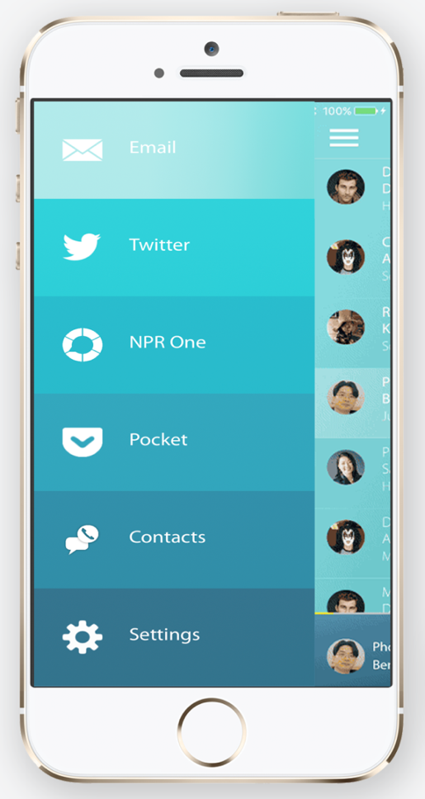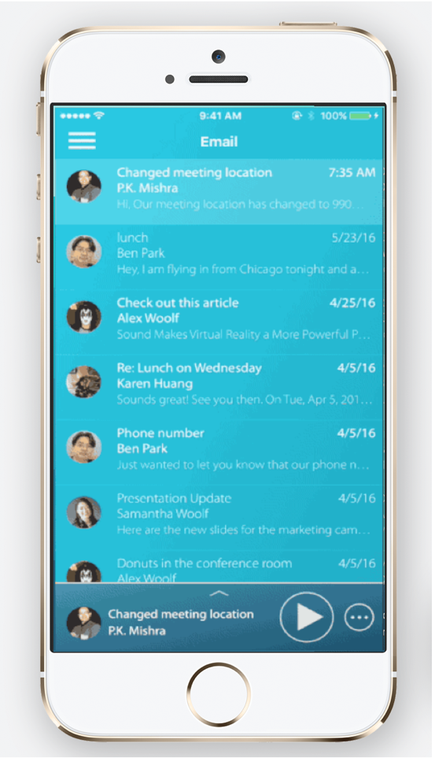
Each channel consists of individual content such as emails or Tweets arranged as a list in temporal order with the most recent content at the top of the list. The bar at the bottom of the screen shows the item that is currently playing or in focus in the list.
You can do the following:
- Tap on any content to toggle Play/Pause of the audio playback.
- Tap on the Play/Pause icon on the bar to resume or pause audio playback.
- Tap on the circle with three dots to bring up the Actions Menu.
- Tap on the Up arrow to reveal a detailed view of the content being displayed.

Email Channel
Currently only Google email accounts (personal or corporate) are supported. We are currently working on expanding support for additional . We currently only support one email account at a time.
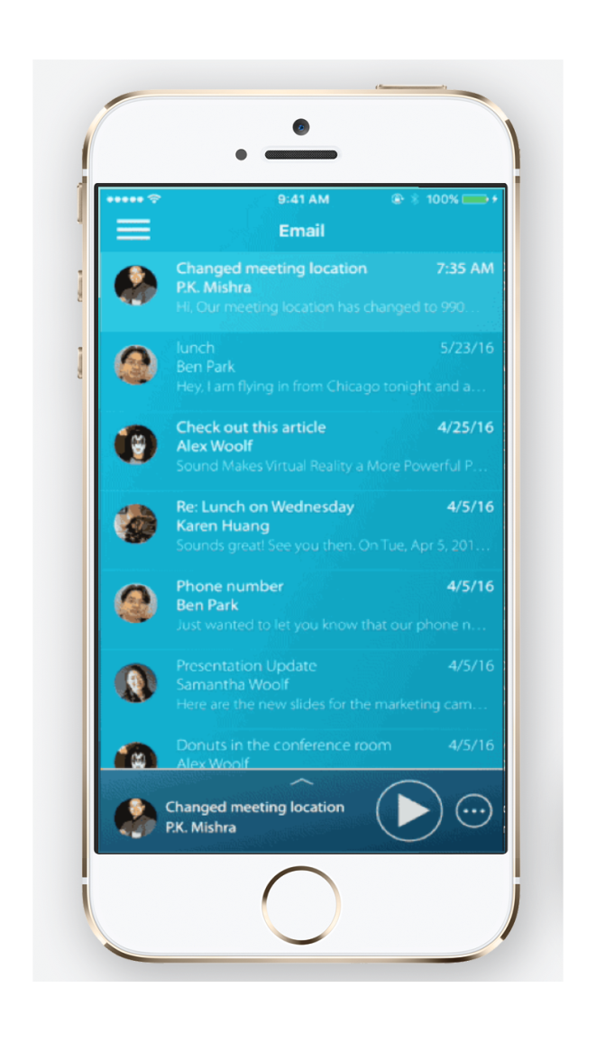
Tip: O6 app can retrieve photos from your Contacts app and match and display it against the email. Allow O6 app access to your Contacts to utilize this feature.

Notifications Channel
The Notifications channels reads aloud your recent alerts from your favorite apps such as Messages, WhatsApp, WeChat, Facebook, Facebook Messenger and more. An incoming notification is automatically added to the Notification Channel. To listen to your notifications, you can navigate to the Notifications channel and scroll through your Notifications.
Your O6 must be connected with your phone for your Notifications channel to receive new Notifications. To receive Notifications from a specific app, you need to enable Notifications for that app on your iPhone.
To enable Notifications from your favorite app on your iPhone:
- Open Settings on your iPhone.
- Tap Notifications.
- Browse to your app and tap on it.
- Set Allow Notifications to ON and keep the App Notifications settings screen open.
- Set Show in Notification Center to ON.

Twitter Channel
The Twitter channel lists Tweets in temporal order with the most recent Tweet at the top. Actions are currently not supported in Twitter.
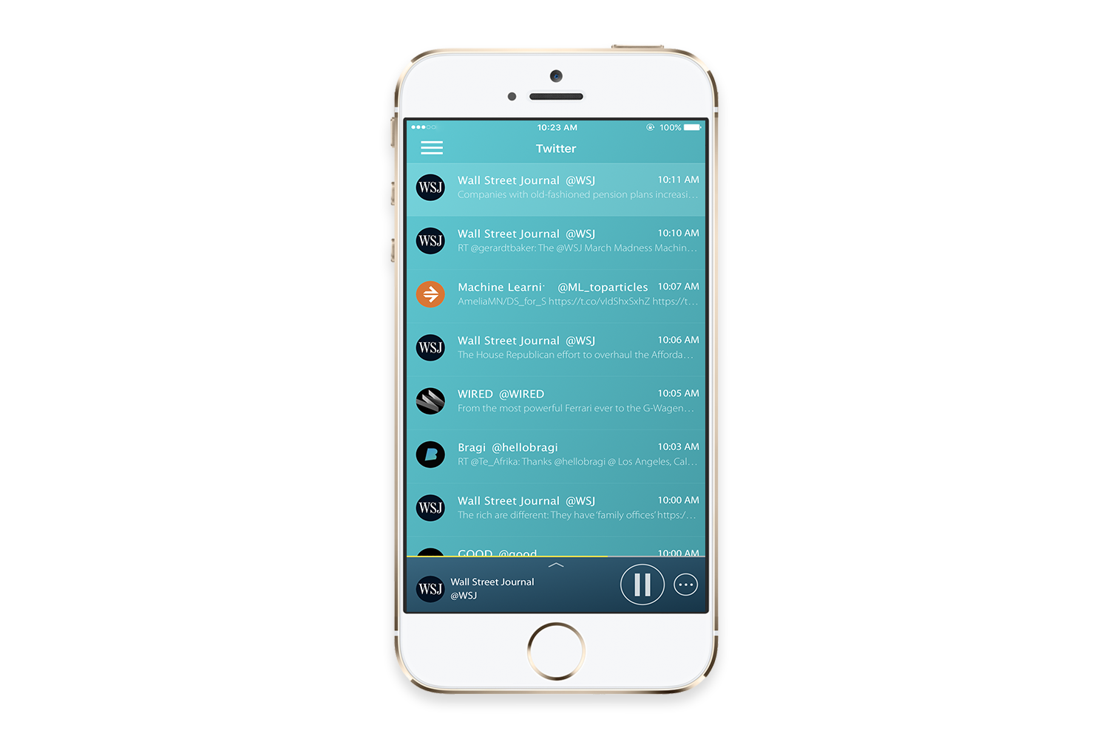

NPR One Channel
The O6 NPR One channel has been developed in partnership with NPR. NPR One delivers rich, local, on demand, and personalized News, and Podcasts delivery.
You can mark News or a Podcast as interesting using the Actions button, or skip to the next News item if you find it uninteresting. NPR One will learn your preferences and personalize the delivery of news. With NPR One you can rewind in increments of 15 seconds until the start of the current audio track, but you cannot go back to earlier tracks.
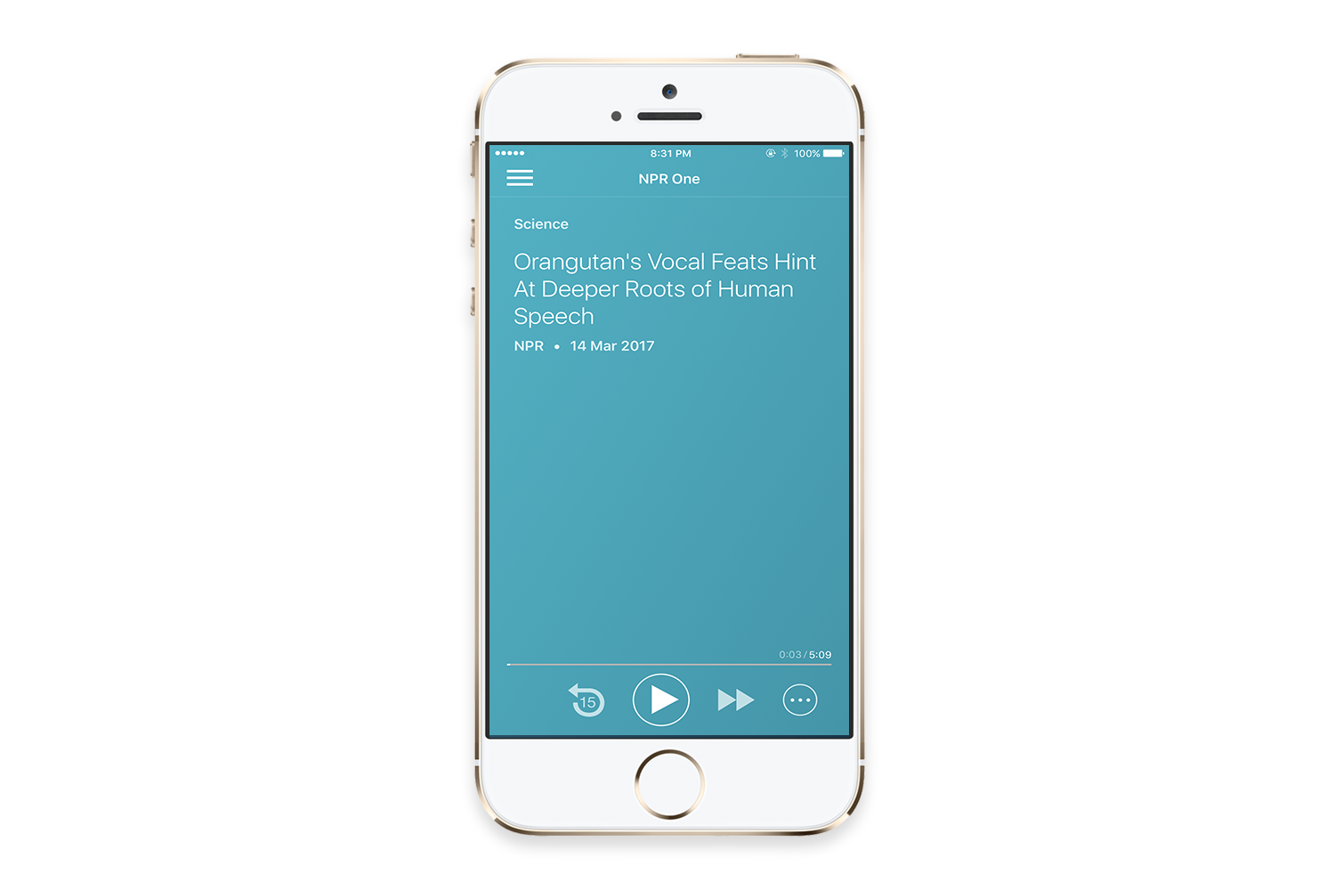
We hope you enjoy your NPR One listening experience.

Pocket Channel
Have you ever come across an important web page but didn't have time to read it? Do you have a reading list that is constantly growing?
Pocket has been added as the newest channel in the O6 App. Pocket is great for saving web articles to read later. And now with O6 you can listen to your articles while you are on the go. More info can be found here: https://getpocket.com/
To set up Pocket with your O6:
- Create a Pocket account easily and for free at https://getpocket.com/
- Install the Pocket Desktop Browser Extension.
This gives you a button to instantly save your current web page into your Pocket. 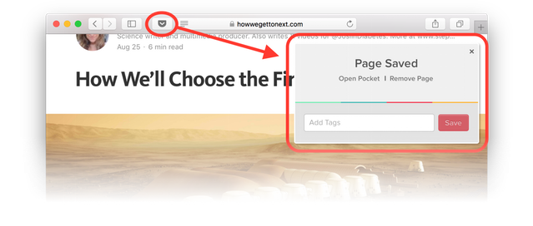
- Install the Pocket App on your phone.
This will let you save articles from your phone’s web browser or apps like Flipboard, News, Pulse, Zite and many, many more (see https://getpocket.com/). 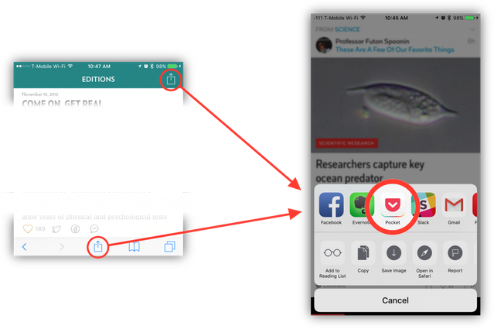
- Listen in the O6 App, or, once you have saved some articles, open the O6 app, and listen to them whenever you like
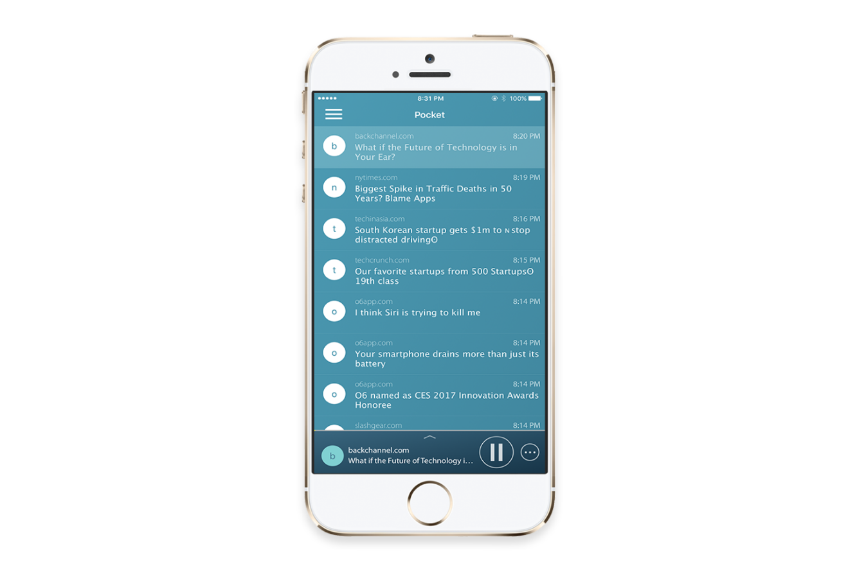

Contacts Channel
O6 provides the capability to make phone calls. You can add your contacts to Favorites for quicker access via the dial. You can add favorites only from recent calls from the O6 app.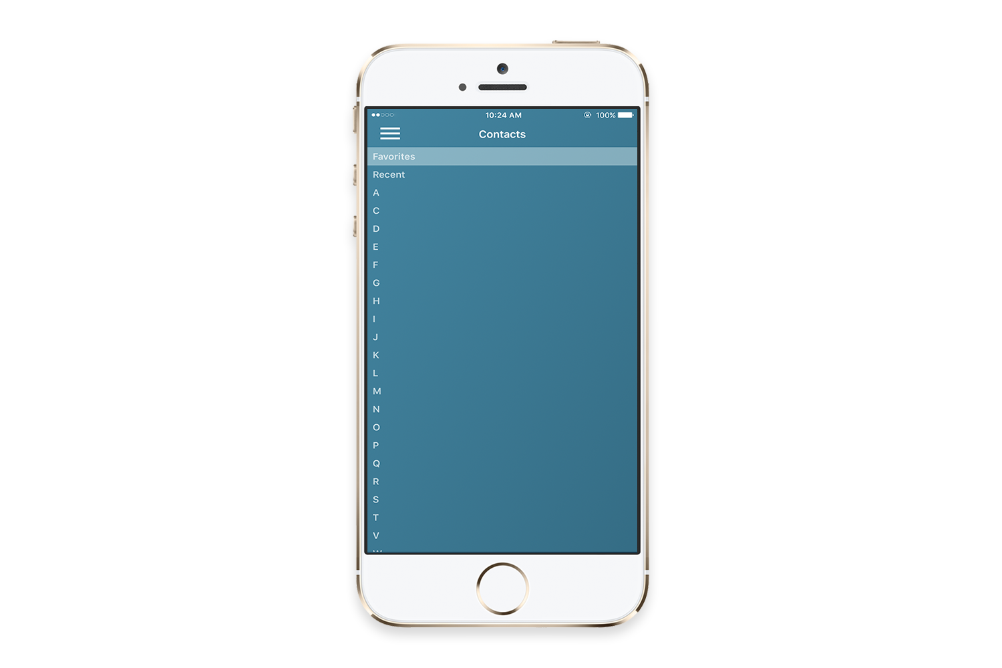
Tip: Because of Apple’s restrictions, the O6 app is unable to initiate phone calls when the phone is locked or when the O6 app is in the background. Please bring the O6 app to the foreground to make phone calls.

O6 App Settings
From the O6 App Main menu, tap Settings to access the following functionality:
- Log into individual accounts for your email, Twitter, NPR One, etc.
- Change your app color theme to match your device color.
- Adjust the Voice Rate and Voice Pitch of narrations.
- Update the software on your device.
- Read the Terms of Service and Privacy Policy.
- Send feedback and questions about the app.

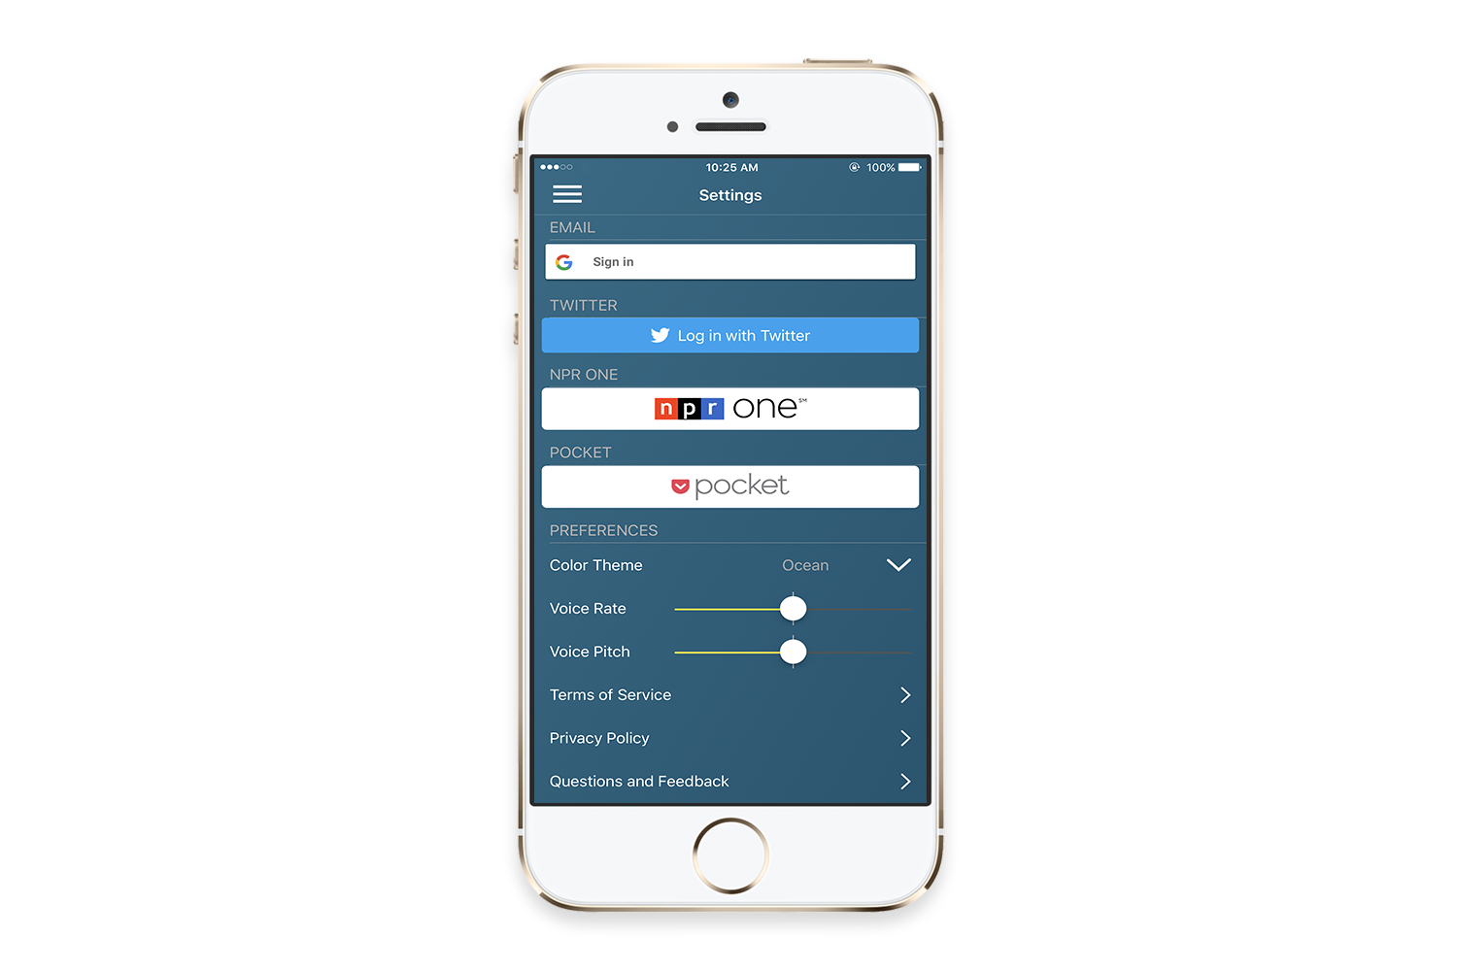

Choosing Different Voices for O6 App
You can choose different Voices to suit your preference for narration in the O6 App. You can also download higher fidelity voices as well. The default voice used in O6 is Samantha Female. To change to other voices, please use the following steps:
To enable Notifications from your favorite app on your iPhone:
- Open Settings on your iPhone.
- Tap General.
- Tap Accessibility.
- Tap VoiceOver.
- Tap Speech.
- Tap Voice.

Performing Actions using O6
Actions are a powerful feature of the O6 experience. When you receive a text or email message, you may need to respond quickly, for example, to reply Yes or No, or to take a specific action like getting directions to a new address. Such interactions typically require you to look at your phone, type, and open and switch between apps. This is inconvenient and dangerous while driving or commuting.
With O6, there is no need to touch, type, or even look at your screen. Simply turn your O6 dial and the device will scroll through and narrate possible action options aloud until you select one of them by clicking the Center button.
Actions enable you to:
- Respond to messages (texts, emails) with a choice of predetermined responses.
O6 uses Artificial Intelligence to analyze the content of you message and present the most likely responses to choose from.
- Take actions on social posts.
You can easily Retweet, Like, or even convert a weblink to audio – all without ever even glancing at your phone’s screen.
- Answer/make phone calls.
O6 automatically extracts names and phone numbers from a message, enabling you to make a phone call as one of the predetermined action options.
- Get directions using your favorite maps app.
O6 extracts addresses from messages, allowing you to automatically navigate to important locations via commonly-used map apps (e.g., Google or Apple Maps).
The range of actions keeps on expanding!

Overview of how Actions Work
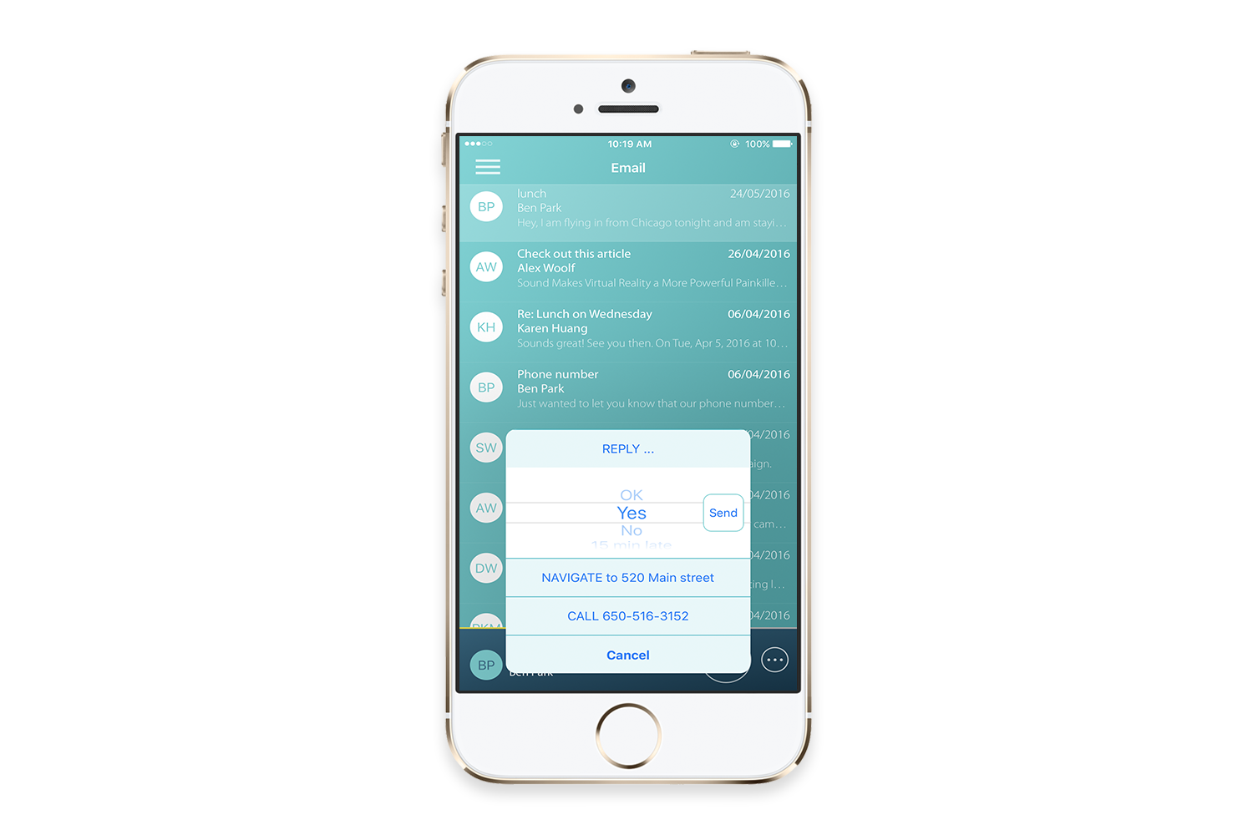
With O6, you can listen to a message — “eyes free”. But how do you respond without looking at or touching your phone? How do you start your maps application and get navigation directions to the new address, without even looking at the phone?
To answer these questions, consider a scenario where O6 is reading a message aloud and you decide that you would like to perform an action. You can do this by doing the following:
- Click the Action button on your O6.
- O6 presents a list of the most-likely actions based on your message content.
- Scroll through the list of actions by turning the bezel dial.
O6 narrates each action as you scroll.
- Click the Center button to select an action and O6 will perform it, for example sending a message or starting the maps app with the navigation directions.
Actions reduce complex interactions involving multiple apps, typing, and unnecessary steps to simple interactions!

Configuring the iPhone for O6 Internationalization
O6 supports over 27 international languages. O6 analyzes your content, such as your emails, using Natural Language Processing. It determines the primary language of the content, and narrates that content in the appropriate language.
Please note that the O6 App only looks for languages that have been added as preferred languages as follows.
To add a language:
- Tap Settings on the iPhone.
- Navigate to General > PREFERRED LANGUAGE ORDER > Add Language
- Languages must be added in order of preference.
Tip: Adding more than two languages may result in longer response times in the O6 App.

Using the O6 App without the O6 Device
The O6 App is much easier, safer, and more fun to use with your O6 device. The O6 device allows complete control of the app without touching your phone. This includes going to the menu, switching channels, and taking actions.
However, if you do not have the O6 device with you, you can use one of these alternative controls to use the O6 app:
- “Old School” tapping: Open the O6 App and tap away.
- Audio Headset: Headsets usually have controls to play/pause (single-click), skip to next track (double-click) or previous track (triple-click).
- Bluetooth Headphones: Most Bluetooth headphones have dedicated buttons for play/pause, previous, and next.
- Lock Screen Control Center: After you start O6, you can lock your phone and the “iOS Control Center” will show up on your lock screen.
- iOS Control Center: Swipe up from just about anywhere in iOS to access controls for Play/Pause, Next, and Previous. This is great for when you are busy using another app, say Pokemon GO, so you can use O6 in the background.
- Car steering wheel: If your car has controls on the steering wheel, you should be able to use Next, Track, and Previous Track buttons to navigate the app. Play/Pause may be on your dashboard, but that should also work.
Note: Check your car manual if you need help connecting your phone to your car’s sound system.

Security and Privacy
Your privacy and security are a top priority for us. For details on our privacy policy, go to: http://www.o6app.com/ios/privacy-policy/
The O6 app signs directly into your email provider and Twitter accounts. Your usernames, email address, passwords, and messages are sent directly from Google and Twitter to your phone. We never see any of it.
Please keep in mind that if someone is close enough to hear, they could overhear O6 content. Also, if someone gets access to your locked phone, they could control the O6 app from the lock screen. If this is a concern, you can play audio from another app after using O6, such as the Music app, to remove O6 access from the lock screen. In the future, we will add other controls so you can manage access to sensitive channels, like email.

FAQ’s

How do I connect my O6 device to my iPhone?
O6 connects to your iPhone via Bluetooth. After charging your O6, navigate to your iPhone’s Bluetooth settings and ensure it is enabled. Click any button on your O6. and it will show up on the Bluetooth setting screen under MY DEVICES. Tap on O6 and then tap Pair in the prompt to connect. Then you are all set.

Does O6 support Android?
O6 currently only supports iOS devices (i.e., iPhone, iPad, iPod). Android support is in the works so please stay tuned.

What languages does O6 support?
O6 currently supports 27 languages. These are: Arabic, Chinese, Czech, Danish, Dutch, English, Finnish, French, German, Greek, Hebrew, Hindi, Hungarian, Indonesian, Italian, Japanese, Korean, Norwegian, Polish, Portuguese, Romanian, Russian, Slovak, Spanish, Swedish, Thai, and Turkish.

How is O6 different from Apple’s Siri or other Voice Command Systems?
The primary purpose of O6 differs fundamentally from systems like Apple’s Siri. O6 is not designed to quickly answer questions or set timers, but rather to perform the complex interactions and browsing tasks that we do every single day with our phones. On average, iPhone users open their phones 80 times a day. This is not typically to look up specific questions or to set a timer. We open our phones to check in on email or social media and this is the problem that O6 solves. O6 is far more reliable, interactive, and usable than voice command systems could ever be.

Does O6 have a speaker?
No, the O6 does not have its own speaker. The O6 app streams audio via Bluetooth to Bluetooth speakers, Bluetooth earbuds, and car audio systems.

What is the Battery Life on the O6?
O6 typically lasts 5–7 days with normal use.

Where can I use O6?
You can use O6 while driving, in the outdoors, walking, running, or simply at home.

How is O6 “eyes free”, when the video shows the app while driving?
We show the app in the video to demonstrate the connection between the O6 device and the app. In practice, we expect drivers to use the app without looking at it because speech feedback with the O6 control makes it easy to navigate the app and listen to messages without interacting with the phone screen at all. The app works in the background and even when the phone is locked.

Why the name O6?
Operating System is abbreviated as OS. O6 is a new operating system that intends to be your 6th sense Operating System, hence the name O6. O6 does not need any visual attention or speech to operate, and it uses sophisticated algorithms to provide a seamless, discreet experience. Even a person staring at you would not know that you are checking your apps and responding to messages.

Why are there two different modes of interacting with apps, when they do similar things?
O6 in Advanced mode can remotely control any mobile application with speech feedback. Yet all mobile apps are designed for visual interaction. As a result, it is inevitable to need to take regular glances at the screen in the Advanced mode. To solve this problem, we created the O6 App, where mobile apps are designed from the ground up for non-visual interaction. The O6 App runs in the background and even when the phone is locked. Over time, we will bring more and more apps into the O6 experience, but until then, you can use the Advanced Mode.

How do I change the volume?
You can triple-click the Ring button to switch the O6 dial to be a volume-control in the Basic mode. Triple-click the Ring button again to switch the dial back to controlling the tracks.

How do I check the battery level?
You can check the battery level of the O6 from the Batteries Widget on your iPhone.

How many O6’s can I connect to one iPhone?
Up to two O6’s can connect to one iPhone without observing any degradation of audio streaming over Bluetooth, but you can simultaneously connect more. We have connected up to ten O6’s to an iPhone without problems.

If you still can’t find the answer to your question, please contact: hi@o6app.com

Other ways to keep up-to-date and get additional support include following us on:
- Twitter / Instagram – @O6app / @O6app
- Facebook – facebook.com/O6app

Technical Specifications
Table 4. List of O6 technical features.

Feature | Details
Media Controller | Works with Spotify, Pandora, Apple Music, YouTube, Netflix, Amazon Video, Podcasts Player, and more.
O6 Companion App | Browsable narration of emails, Twitter, Saved Articles, Evernote, radio, telephone, and more.  Browsable narration of notifications from Text, WhatsApp, Wechat, Facebook Messenger, Facebook, and hundreds of other apps.
Actions | Respond to messages (texts, emails) with a choice of predetermined responses; act on social posts; answer/make phone calls; get navigation directions using your favorite maps app, and more.
Supports over 27 international languages
Battery: | Rechargeable battery with charge lifespan of 7–10 days.
Embedded Voice commands | Remote activation of Siri and Google Now.
Haptic motor | Can play over 200 dynamically selectable haptic effects.
Ultra-low-power, high performance three axes linear accelerometer
Accessories | Magnetic steering wheel mount, a suede-brown or white wrist band, and a clip mount.
Bluetooth integration | Integrated with car audio systems, touchscreen display, and limited steering wheel controls over Bluetooth.
App works even when phone is locked or app is in the background
iOS Voiceover | O6 supports a special mode for visually impaired users, facilitating navigation of iOS screens with VoiceOver turned on. With O6, you can navigate the screen using the following: Next item, Previous item, Activate item (e.g., open app), Magic tap, Home, Change Rotor setting, Adjust rotor setting, and more.
Multi-modal | O6 modes can be changed by pressing-and-holding the Center button until you feel haptic buzzes. A single buzz indicates the Basic Control mode (control Media and the O6 app) while a double buzz indicates the iOS VoiceOver Basic App Control mode.

New User Setup Tips
- The iPhone’s on-screen virtual keyboard disappears when O6 is connected. You can show (or hide) the virtual keyboard by triple-clicking the Center button. The text field needs to be in focus to activate this setting. Alternatively, you can turn Bluetooth Off on the iPhone or press and hold the Center button for 5 seconds until you feel and hear the haptic buzz to turn O6 off. Either of these steps result in the virtual keyboard showing onscreen.

- Due to compliance issues with Apple iOS version 10, we’re proactively working to restore the Siri functionality using O6. A software update on O6 temporarily disables Siri functionality until the issue is resolved by Apple. If however Siri is enabled, in some situations, after activating Siri using the O6, the iPhone stops responding to O6. You have to unpair and repair O6 to resume normal operations. We are actively working with Apple to resolve this issue.

- We recommend regularly keeping both your O6 App as well as O6 firmware up to date to resolve potential issues.

Future Developments
- Due to compliance issues with Apple iOS version 10, we’re proactively working to restore the Siri functionality using O6. A software update on O6 temporarily disables Siri functionality until the issue is resolved by Apple. If however Siri is enabled, in some situations, after activating Siri using the O6, the iPhone stops responding to O6. You have to unpair and repair O6 to resume normal operations. We are actively working with Apple to resolve this issue.

- There is sometimes an issue where the firmware update does not start, even though the O6 device is connected. To resolve this issue, please click the iPhone’s Home button and then bring the O6 App to the foreground again.
- While the O6 app supports over 27 international languages, the app itself is not internationally localized. That means that while the content will be adapted to and narrated in the languages you configure, the O6 App Main menu will remain in English.

